HONEYPOT LAB ACTIVITY REPORT
Cowrie SSH Honeypot Setup and Troubleshooting

Student Name | Trail Bajenting
Course / Section | ________________________________
Date Submitted | ________________________________

1. Introduction
A honeypot is a security tool designed to attract and record connection attempts so that activity can be observed in a controlled environment. Cowrie is a honeypot that emulates SSH and Telnet services and can record attempted logins and commands.
In this activity, Cowrie was run in a Docker container on a Windows computer. Kali Linux was used as the test client to try to connect to the honeypot through the Windows host-only network.

2. Objectives
- Understand the purpose of a honeypot and the basic role of Cowrie.
- Verify that the Cowrie container is running and its port is published.
- Test connectivity from Kali Linux to the Windows host.
- Use logs and network commands to identify a connection problem.

3. Tools and Environment
Component | Configuration
Windows host | Docker Desktop is running Cowrie.
Cowrie image | cowrie/cowrie:latest; container name: cowrie-win.
Windows host-only IP | 192.168.56.1/24.
Kali Linux IP | 192.168.56.101/24.
Published port | TCP 2222 mapped to 192.168.56.1:2222.
Tools used | Docker, PowerShell, netcat (nc), SSH, Windows Firewall log.

4. Lab Network Diagram
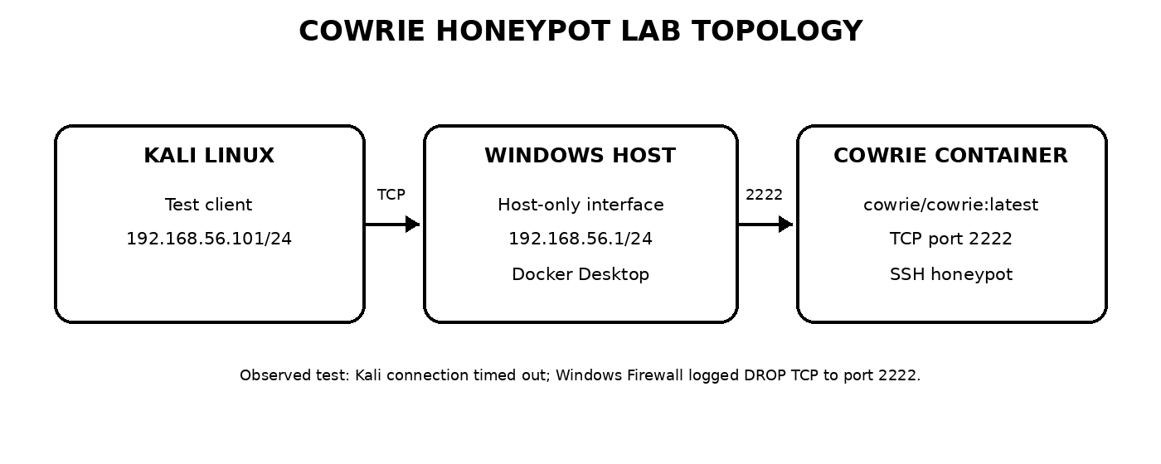
Figure 1. The intended connection path from Kali Linux to Cowrie through the Windows host.

5. Procedure
1. Verify the container: On Windows, run `docker ps --filter "name=cowrie-win"` to check that the Cowrie container is running.
2. Verify the port mapping: Run `docker port cowrie-win` to confirm that TCP port 2222 is published on 192.168.56.1.
3. Review the container logs: Run `docker logs --tail 15 cowrie-win` to check Cowrie startup messages.
4. Test from Kali Linux: Run `nc -vz -w 3 192.168.56.1 2222`. An SSH connection can be attempted with `ssh -p 2222 root@192.168.56.1`.
5. Check Windows Firewall logs: Run `Get-Content "$env:windir\System32\LogFiles\Firewall\pfirewall.log" -Tail 20` in PowerShell to look for blocked traffic.

6. Results and Discussion
The Cowrie container was shown as running, and Windows reported that TCP port 2222 was listening on 192.168.56.1. However, the connection attempt from Kali Linux did not succeed.
Test | Observed result
Container status | Running.
Windows port status | TCP port 2222 was listening on 192.168.56.1.
Kali netcat test | Connection timed out.
Firewall log | DROP TCP entries showed packets from 192.168.56.101 to 192.168.56.1 on destination port 2222.
The firewall log provides evidence that Windows recorded the incoming TCP connection attempts as dropped. This is consistent with the timeout seen in Kali. A successful SSH session was not confirmed, so the activity should be considered partially completed until the blocking rule or packet-filtering issue is resolved and the connection is tested again.

7. Security Considerations
- Run the honeypot only in an authorized and isolated lab network.
- Use dummy usernames and passwords; never enter real credentials.
- Do not expose the service to the public internet without explicit authorization and appropriate isolation.
- Avoid turning off Windows Firewall globally. If a rule change is needed, limit it to the lab host, Kali IP, TCP port 2222, and the duration of the exercise.
- Review the logs and stop the container when the lab is finished.

8. Conclusion
This activity introduced the basic setup of a Cowrie SSH honeypot using Docker and the use of Kali Linux to test connectivity. The container was running and the Windows port was listening, but Kali could not establish a connection. The Windows Firewall log recorded matching TCP drops to port 2222. The next step is to resolve the specific firewall or packet-filtering issue and repeat the test. A successful connection and Cowrie interaction logs should only be reported after they are observed.

9. Evidence
Evidence collected during troubleshooting includes the running-container check, port mapping and listening-port checks, the Kali netcat timeout, and Windows Firewall log entries showing dropped TCP packets. Screenshots or copied terminal output can be attached if required by the instructor.

